
JOURNEY MANAGEMENT PLAN
(JMP)

FROM: TOK BALI SUPPLY BASE
TO: KEMAMAN SUPPLY BASE

Description | Name | Company | Approved
Prepared By | Miishan | Glow Freight Services (M) Sdn Bhd
Reviewed By | Mr Muhun | Glow Freight Services (M) Sdn Bhd
Reviewed By | C&P LOGISTICS SDN BHD
Approved By

Contents

1.0 INTRODUCTIONS. 3
1.1 Objective…………………………………………………………………………………………………. 3
1.2 Definitions and Abbreviations…………………………………………………………………………… 3
1.3 Description of Route……………………………………………………………………………………...3
1.4 Cargo description and shipment information…………………………………………………………… 3
2.0 Route Map………………………………………………………………………………………………….. 4
2.1 Overall Journey…………………………………………………………………………………………... 4
3.0 ROUTE SUMMARY………………………………………………………………………………………….. 5
4.0 DRIVING REQUIREMENTS.…………………………………………………………………………………. 5
5.0 HAZARD IDENTIFICATION…………………………………………………………………………………... 5
5.1 General Hazards.………………………………………………………………………………………… 6
6.0 CONTROLS………………………………………………………………………………………………….. 6
6.1 Specific Controls.………………………………………………………………………………………… 6
6.2 General Controls.………………………………………………………………………………………… 6
7.0 DRIVER DETAILS…………………………………………………………………………………………….. 7
8.0 RECOVERY.…………………………………………………………………………………………………. 8
9.0 EMERGENCY RESPONSE…………………………………………………………………………………… 8
9.1 Emergency Contact List.……………………………………………………………………………… 8
10.0 ROUTE/ AREA JMP SUMMARY FORM.………………………………………………………………….. 9
10.1 Journey Management Plan: Description of Route/ Area.…………………………………………….. 9
10.2 HEMP (Hazard and Effect Management Plan) Summary.……………………………………………. 9
11.0 CONSEQUENCE MANAGEMENT.………………………………………………………………………… 10
11.1 Driver………………………………………………………………………………………………….. 10
11.2 Truck …………………………………………………………………………………………………..10
11.3 Delivery Schedule…………………………………………………………………………………….. 10

INTRODUCTIONS

1.1 OBJECTIVE

This section briefly describes the operational aspects involved in inland transportation. The purpose of this study is to provide preliminary input regards to the handling of Reel Assembly Skid. The cargo shall be transport from TOK BALI SUPPLY BASE to KEMAMAN SUPPLY BASE.

Any numbers, data and drawings used are for reference only and subject to final approval. All relevant drawings and diagrams are included after the text portion and must be read in conjunction with the text presentation or description and cross referenced where necessary.

1.2 DEFINITIONS AND ABBREVIATIONS

Cargo : REEL ASSEMBLY SKID
Client : GLOW FREIGHT SERVICES (M) SDN. BHD.
COG : Centre of gravity

1.3 DESCRIPTION OF ROUTE.

ROUTE | TOK BALI SUPPLY BASEto KEMAMAN SUPPLY BASE
DATE OF ASSESSMENT | 29/08/2024
COMPLETION POINT | KEMAMAN SUPPLY BASE
DISTANCE | 266 KM
EXPECTED DURATION OF JOURNEY | 4 - 5 HOURS
ROAD TYPE | ROAD PAVEMENT WITH BLACKTOP PREMIX SURFACED. GENERALLY, IN GOOD CONDITION
SPEED LIMIT | 60 - 80 km/h
TERRAIN | MOSTLY FLAT
WEATHER OF TIME ASSESSMENT | FINE WITH CLEAR SKIES, 34°C – 36°C

1.4 CARGO DESCRIPTION AND SHIPMENT INFORMATION

General drawings, dimensions, weights, COGs and saddle positions shall be provided by the client.

We will look at these features to determine the best transportation method. Description of cargo information

3

2.0 Route Map

2.1 Overall Journey

From: TOK BALI SUPPLY BASE to KEMAMAN SUPPLY BASE . Distance: 266 KM

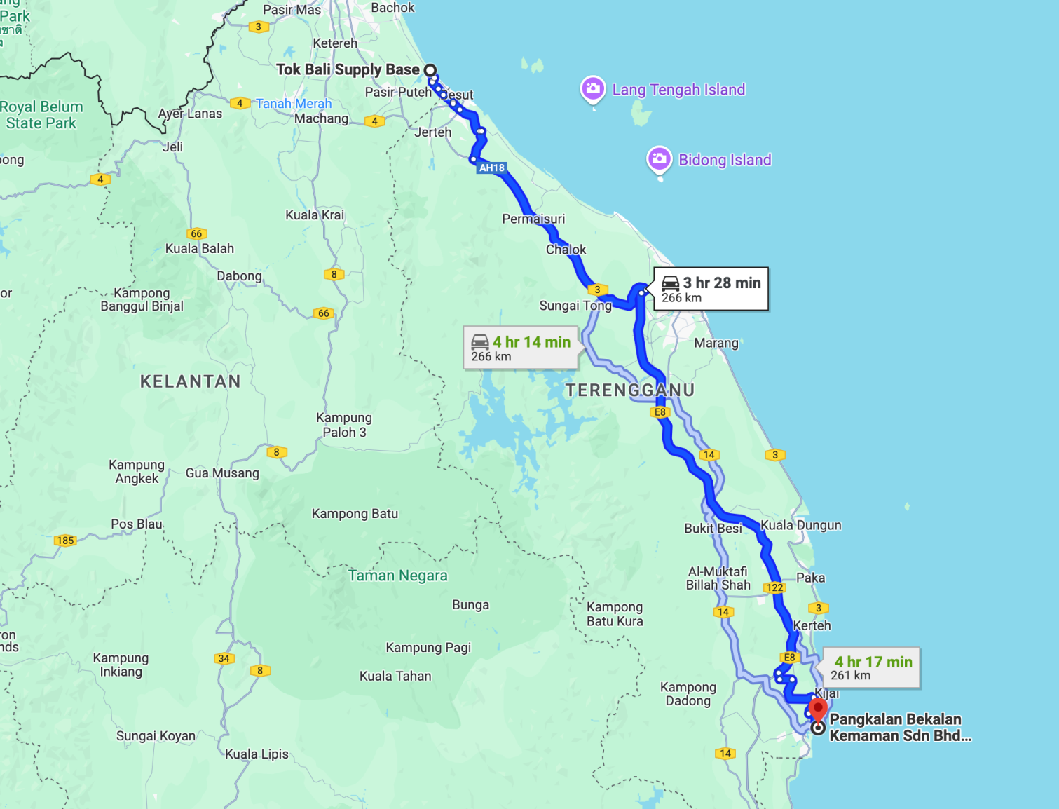

3.0 ROUTE SUMMARY

The route covers less than 266 km across mostly flat with slight uphill and downhill road that runs through industrial area and expressway. The speed limit is 60 - 80 km/h along the state road. The route covers two lanes with full tarmac road with street lighting on approaching each exit and intersection. Expected sunny and clear skies throughout the month of July to Augest. Communication along the route has good cell phone signals.

4.0 DRIVING REQUIREMENTS.

• Each truck driver needs a valid driving license and to attend the Defensive Driving Course.

5.0 HAZARD IDENTIFICATION

5.1 General Hazards.

General Hazards will apply more to an area, rather than a route e.g. for a Town or City assessment. These include:

- Driver Behaviour / Local Driving Culture, e.g.: speeding, road indiscipline or indiscipline at lights, undertaking, and general road infrastructure.

- (VEH453 T/WC4448 with cargo) Note that minimum height clearance is 5000 MM (Overhead bridges at the highway)

- This shipment is feasible to transport cargo from TOK BALI SUPPLY BASE to KEMAMAN SUPPLY BASE

6.0 CONTROLS

6.1 Specific Controls.
Third-party certified training company assessed competent in an approved Defensive Driving Course is recommended to drive employees/contractors in a vehicle/truck that complies with the standards should be briefed of the following if there is a necessity to travel by road:
• General Awareness of the poor driving discipline of other road users especially heavy goods vehicles.
• Be aware while approaching junctions within the Industrial Area. • Adhere to the Compound Area speed limit.
• Recognition of weather extremes and adjusting driving behaviours accordingly.

6.2 General Controls.
Inspect the conditions of the vehicle with the standard checklist provided and report any defect(s) found immediately:
• Always exercise Defensive Driving stringently during the journey.
• Inspect the condition of the vehicle with the checklist provided and report any defect/s found immediately.

Ensure that the vehicle is equipped with: • 1 pc. Reflective hazard triangle.
• First-aid kit and flashlight/torch.
• 1 pc. 9 kg. Multi-purpose Dry powder fire extinguisher.
• In Vehicles Monitoring System or equivalents to track the vehicle's location, speed, idling time, and web-based monitoring functionality.
• Wheel choker to be placed behind the truck wheel to prevent accidental movement while stopping at the designated area.

Ensure that the driver:
• Has a valid driving license.
• Is not under the influence of drugs and alcohol while driving. • And passengers always wear seat belts.
• While driving does not use your phone. • Complies with the speed limits.
• Carry a high-visibility jacket for the Driver to be used in case of emergency stops. • Follow the prescribed Journey Management Plan.
• Reacts to the dynamic situation of the road condition & environment. • Keeps a safe distance from the vehicle in front
• Has enough rest before all journeys.
• Stops when feeling tired and follows recommended break and journey durations.
• Switches on dipped headlights during all journeys.

7.0 DRIVER DETAILS

- Driver Name: SHAMRI BIN AB RAHMAN
- Driver IC No:730118-11-5001
- Mobile No: +60 102709749
- Truck No: VEH453
- Trailer No: T/WC4448

8.0 RECOVERY.

In all Road Transport accidents, delays, or changes that affect Journey Management Plan that is captured under Journey Management Plan, the Journey Manager should be informed immediately.

Wherever possible, staff should contact/communicate their Journey Manager, or the agreed emergency numbers as a backup in the relevant Asset or organization.

9.0 EMERGENCY RESPONSE

9.1 Emergency Contact List.

Bil | Name | Contact
1. | Glow Freight Hotline | 1800-88-0098
2. | Glow Freight Services (M) Sdn Bhd | 03-33625017
3. | Saravanan Subramaniam (OPS manager) | 012-9899749
4. | PLUS / ELITE/Second Link Expressway Careline | 1800-88-0000
5. | LPT 1 Careline | 019-594 9333
6. | LPT 2 Careline | 1800-88-0220
7. | Guthrie Careline | 1300-88-0035
8. | Karak Expressway | 03-91732020
9. | Emergency Speed dial | 999
10. | JKR Hulu Perak (Gerik) | 05-791 1040

10.0 ROUTE/ AREA JMP SUMMARY FORM.

10.1 Journey Management Plan: Description of Route/ Area.

Route | TOK BALI SUPPLY BASE to KEMAMAN SUPPLY BASE.
Date of Assessment | 29/08/2024
Start Point | TOK BALI SUPPLY BASE
Completion Point | KEMAMAN SUPPLY BASE.
Distance | 266 KM
Expected of Duration of Journey | 4 - 5 hours
Road Type | Road pavement with blacktop premix surface and  generally, in good condition and acceptable.
Speed Limit | 60 - 80 km/h
Terrain | Mostly flat
Weather at Time of Assessment | Fine with clear skies; 34 °C - 36 °C

10.2 HEMP (Hazard and Effect Management Plan) Summary.

Hazards | Controls | Comments
This Route will encompass: | General awareness of the poor driving discipline of other road users especially motorcyclists and heavy good vehicles. | Speeding vehicles in Port
Junction- Heavy traffic exiting and entering. | Recognition of the weather extremes and adjusting driving behaviours | Compound Area.
Wind, thunderstorms, and heavy rain could cause slippery roads | Follow speed limit on certain areas that shown the signage. | Bad driving behaviour.
Reduced vision/ visibility | Designated truck drivers MUST complete proper Defensive Driving training. | Watch out when joining and exiting a junction. Keep correcting lane and give ample time indication when need to change lane.

11.0 CONSEQUENCE MANAGEMENT.

11.1 Driver
To ensure the contractor driver, comply with Journey Management Plan for this project, Glow Freight Services (M) Sdn Bhd shall impose the following for non-compliance:
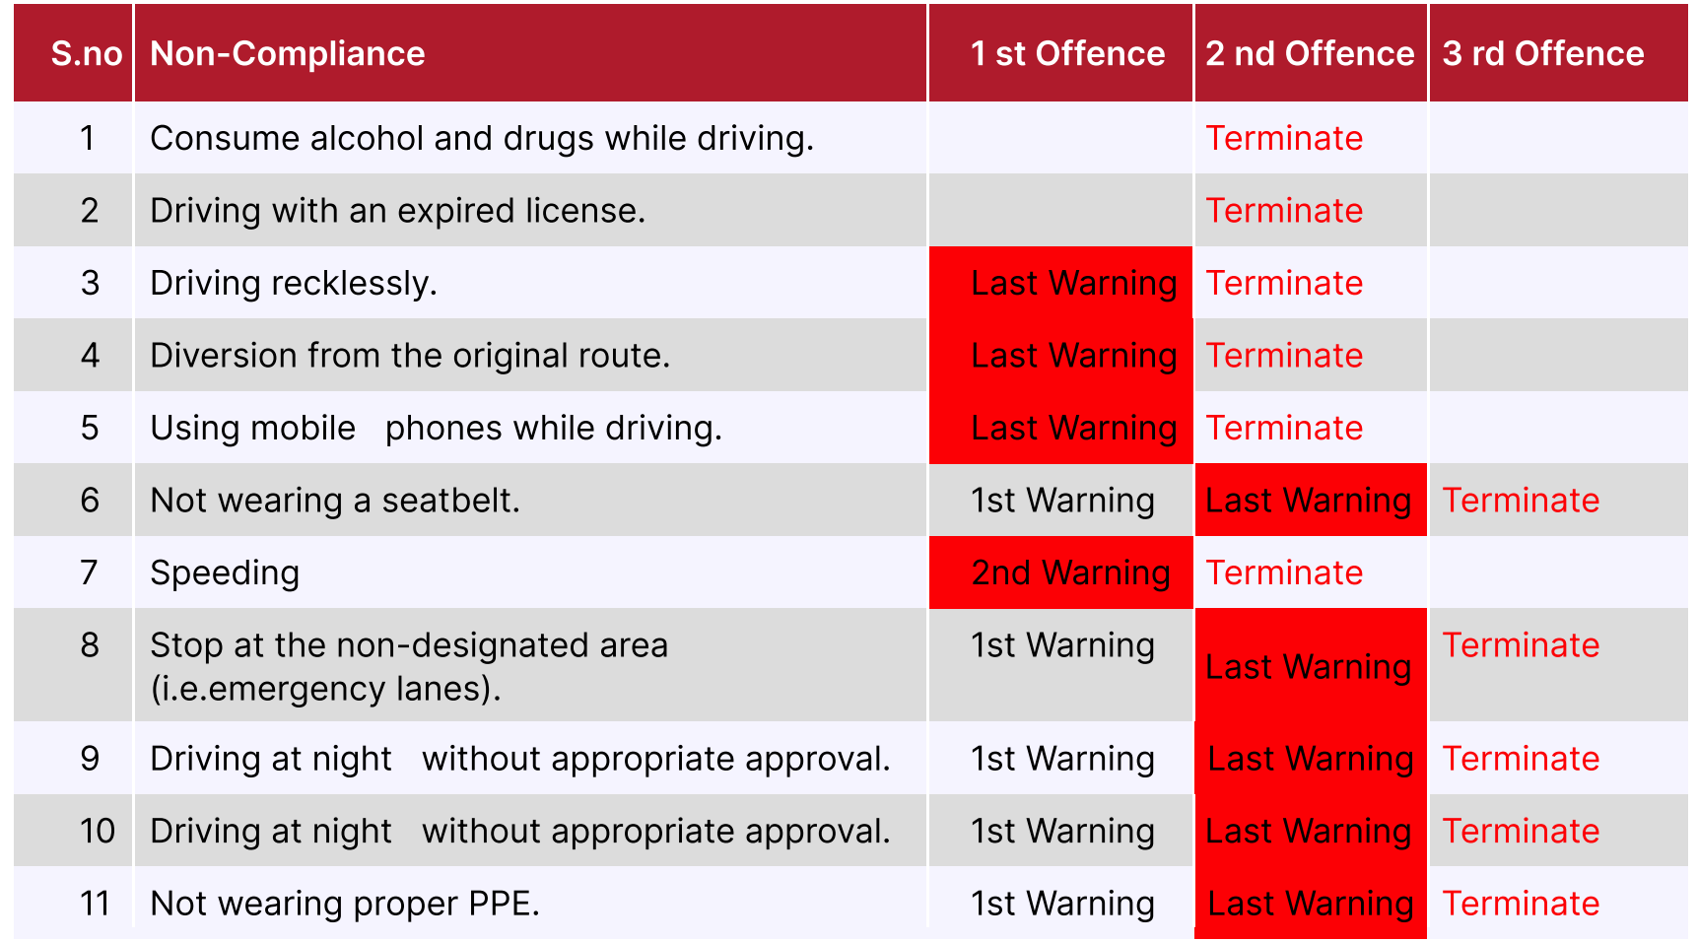

Note: Drivers who have been terminated must be replaced by the contractor with the same capacity and have a valid Defensive Driving Certificate. The contractor shall bear the cost of the Defensive Driving Course for the said driver.

11.2 Truck
Glow Freight Services (M) Sdn Bhd shall reject the truck supply by the contractor if the truck condition is not roadworthiness or comply with our Road Transportation Safety Guidelines. The cost of the truck replacement shall be bear by the contractor.

11.3 Delivery Schedule.
Delivery of cargo will be by 29/08/2024.

