



FROM: TOK BALI SUPPLY BASE

TO: KEMAMAN SUPPLY BASE

Description | Name | Company | Approved
Prepared By | Miishan | Glow Freight Services (M) Sdn Bhd
Reviewed By | Mr Muhun | Glow Freight Services (M) Sdn Bhd
Reviewed By | DHL Global Forwarding
Approved By

 | Subject: Method Statement – In-land Transportation
 | Client: C&P LOGISTICS SDN BHD
 | Project: Transportation from TOK BALI SUPPLY BASE to KEMAMAN SUPPLY BASE
 | Doc: OOG/24-1 | Revision: 00 | Date: 29/08/2024 | Description: Issued for Review | Initial: Miishan

INDEX

1.0 INTRODUCTION.

1.1 SCOPE OF WORK.

1.2 CARGO DESCRIPTION.

2.0 HSE REQUIREMENTS.

2.1 ORGANIZATION CHART AND COMMUNICATION FLOW.

3.0 RESPONSIBILITIES.

4.0 TRANSPORTATION MATRIX.

5.0 OPERATION PROCEDURE.

5.1 PREPARATION WORK.

5.2 RECEIVING ON TO TRAILER

5.3 LASHING CARGO ONTO TRAILER.

5.4 INLAND TRANSPORTATION.

6.0 EQUIPMENT.

7.0 PRELIMINARY CHECK BEFORE STARTING OPERATIONS.

8.0 CONTINGENCY AND EMERGENCY PLAN.

9.0 HAZARD IDENTIFICATION RISK ASSESSMENT RISK CONTROL.

10.0 FATIGUE MANAGEMENT.

11.0 APPENDIX.

 | Subject: Method Statement – In-land Transportation
 | Client: C&P LOGISTICS SDN BHD
 | Project: Transportation from TOK BALI SUPPLY BASE to KEMAMAN SUPPLY BASE
 | Doc:OOG/24-1 | Revision: 00 | Date: 29/08/2024 | Description: Issued for Review | Initial: Miishan

1.0 INTRODUCTION.

1.1 Scope of Work.

The scope of work contained in this Method Statement is to explain to the Client and the Owner how to perform job execution for the following operations:

• Preparation of trailer as per design configuration and standby at the loading area.

• Receiving of cargo from the loading point onto the trailer.

• Secure the cargo on the trailer.

• In-land Transportation.

• Positioning of the trailer to the designated unloading location.

This Method Statement shall meet all engineering, documentation, preparation, and execution requirements of the operation. It is also used to get the requested approval and to ensure the safe and efficient execution of the operations.

1.2 Cargo Description

Following is the summary of the heavy cargo given by the client:

Cargo Picture

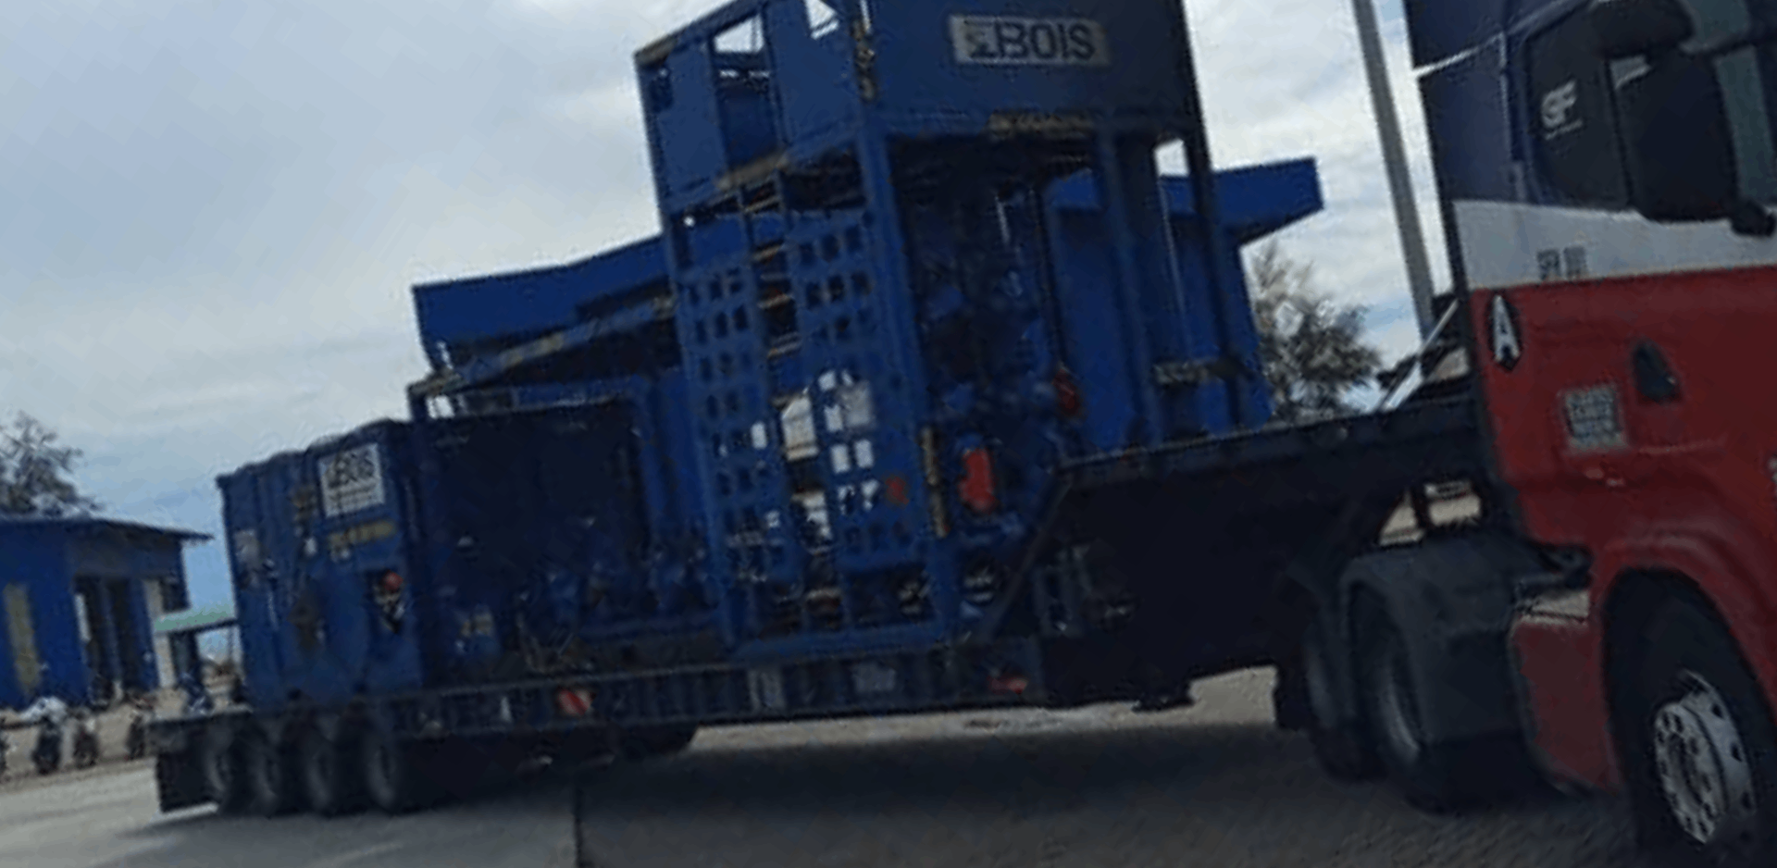

 | Subject: Method Statement – In-land Transportation
 | Client: C&P LOGISTICS SDN BHD
 | Project: Transportation from TOK BALI SUPPLY BASE to KEMAMAN SUPPLY BASE
 | Doc:OOG/24-1 | Revision: 00 | Date: 29/08/2024 | Description: Issued for Review | Initial: Miishan

2.0 HSE REQUIREMENTS.

Ensure that truck loading and unloading operations are completed safely and comply with the
regulations for oversized cargo meets safety requirements.

• Carry out an Operational Meeting with all involved parties.
• Carry out toolbox meetings/ safety briefing before the execution of the load-out operations to communicate the hazards associated with the operation and actions taken/ safety measures to minimize the risk.
• Ensure that personnel not directly involved in this operation are kept away from the operation.
• Ensure the cargo is transported according to JMP.
• Every personnel involved must wear the necessary PPE.
• Pre-departure checks to be completed on all equipment before job execution.
• In the event of an emergency/incident during the operation, the personnel involved in the operation must follow the client’s emergency response procedures at all times. Coordination with the site representative is a MUST.

 | Subject: Method Statement – In-land Transportation
 | Client: C&P LOGISTICS SDN BHD
 | Project: Transportation from TOK BALI SUPPLY BASE to KEMAMAN SUPPLY BASE
 | Doc:OOG/24-1 | Revision: 00 | Date: 29/08/2024 | Description: Issued for Review | Initial: Miishan

3.0 SITE ORGANIZATION CHART AND COMMUNICATION FLOW.

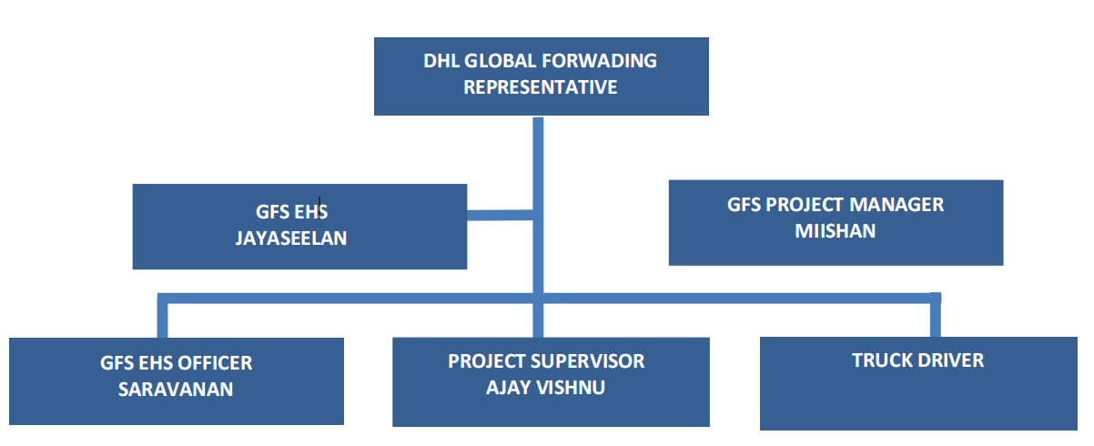

 | Subject: Method Statement – In-land Transportation
 | Client: C&P LOGISTICS SDN BHD
 | Project: Transportation from TOK BALI SUPPLY BASE to KEMAMAN SUPPLY BASE
 | Doc:OOG/24-1 | Revision: 00 | Date: 29/08/2024 | Description: Issued for Review | Initial: Miishan

4.0 RESPONSIBILITY MATRIX.

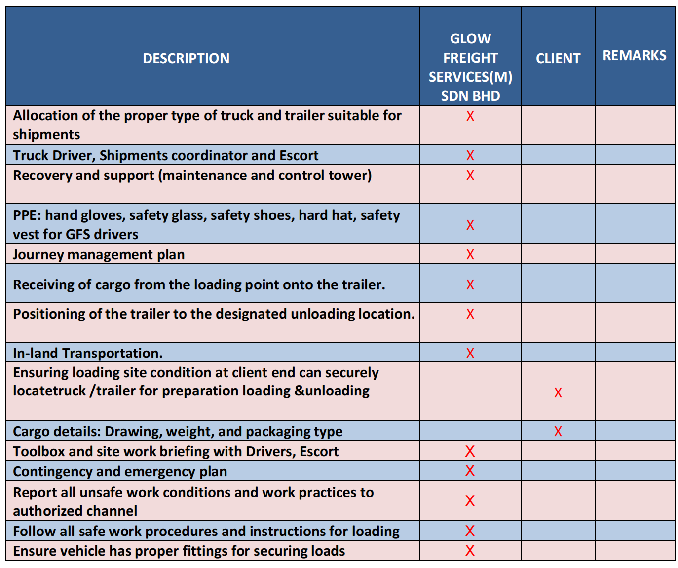

 | Subject: Method Statement – In-land Transportation
 | Client: C&P LOGISTICS SDN BHD
 | Project: Transportation from TOK BALI SUPPLY BASE to KEMAMAN SUPPLY BASE
 | Doc:OOG/24-1 | Revision: 00 | Date: 29/08/2024 | Description: Issued for Review | Initial: Miishan

5.0 OPERATION PROCEDURE.

5.1 Preparation Work.
1. Use the right truck for transporting the load.
2. Ensure truck has proper fittings for securing loads.
3. Check the condition of the truck, trailer rack to ensure it is fit for requirements.
4. Inspect all the lashing, chain block, and PPE items condition.
5. Positioning of the truck/trailer to the loading site

5.2 Receiving on to Trailer
1. The cargo loading process follows according to the loading plan shown in the technical drawing.
2. The lashing should comply with the approval in the drawing/procedure.

5.3 Lashing onto Trailer.
1. Lash the cargo according to technical drawing instructions to prevent movement when transporting.
2. The strong point needs to secure with a chain, and the lever block secured
with a cargo lashing belt.
3. Lashing without drawings will be decided by the client'stechnical supervisor.
4. After the written approval of the customer/appointed surveyor, the cargo is
shipped to the destination.

5.4 Inland Transportation.
1. Loading operations will be carried out in good weather conditions.
2. Loading operations will be put on hold under the customer’s instructions,
during bad weather conditions, or when there is a breach of safety.
3. After the cargo is securely loaded to the trailer according to the transportation
arrangement drawing and the customer/designated surveyor's signature
approval is obtained, the truck is ready to start the journey to the destination.
4. The driver follows the JMP approved by the customer.

 | Subject: Method Statement – In-land Transportation
 | Client: C&P LOGISTICS SDN BHD
 | Project: Transportation from TOK BALI SUPPLY BASE to KEMAMAN SUPPLY BASE
 | Doc:OOG/24-1 | Revision: 00 | Date: 29/08/2024 | Description: Issued for Review | Initial: Miishan

6.0 EQUIPMENTS.

6.1 Trailers.
- ONE unit of Low Loader
6.2 Lashing Accessories.
- Supply of sufficient metal chains.
- Supply of sufficient cargo belts.
* Please refer to the transport arrangement drawing.

7.0 PRELIMINARY CHECK BEFORE STARTING OPERATIONS.
Before starting the loading operations, the following checks will be carried out by Glow Freight
• Weather conditions are suitable to start the loading operation.
• Ensure all spare backup equipment/materials are available at the site.
• Verify transport information with all parties.
• All equipment has been functionally inspected and is in a good condition. (truck
trailer, lashing, and PPE)
• Toolbox meeting has been carried out and signed.
• All required personnel are available for loading operation.

8.0 CONTINGENCY AND EMERGENCY PLAN.
In the event of an emergency/incident during the operation, the driver should contact
personnel involved in the operation must always follow the given emergency contact matrix.

The contact matrix personnel are:

NO | PHONE NUMBER | REMARKS
1. | 999 | EMERGENCY CALL CENTER
2. | 019-386 3879 | DHL GLOBAL FORWARDING
3. | 010-362 9749 | MIISHAN- GFS REPRESENTATIVE

 | Subject: Method Statement – In-land Transportation
 | Client: C&P LOGISTICS SDN BHD
 | Project: Transportation from TOK BALI SUPPLY BASE to KEMAMAN SUPPLY BASE
 | Doc:OOG/24-1 | Revision: 00 | Date: 29/08/2024 | Description: Issued for Review | Initial: Miishan

9.0 HAZARD IDENTIFICATION RISK ASSESSMENT RISK CONTROL

Company | : | Glow Freight Services (M) Sdn Bhd |  | Job Activity | : | OOG in-land transportation
Project Name | : | Transportation from TOK BALI SUPPLY BASE to KEMAMAN SUPPLY BASE
Prepared by | : | Signature | :
 |  | Name | : Miishan |  |  | Name | : Miishan
 |  | Date | : 29/08/2024 |  |  | Date | : 29/08/2024

HAZARD IDENTIFICATION |  |  |  | RISK ASSESSMENT |  |  |  | RISK CONTROL
No | Work Activity | Hazard | Consequences | Existing Risk Control | Likelihood | Severity | Risk | Control Measure | Person in Charge (Due Date)
1.0 | Pre- Operation
1.1 | Truck parking at client premise. | Parking truck at the road shoulder. | The truck was hit by a third-party vehicle. | - Truck attached with reflector sticker.  - Put safety cone during parking.  - Switch on the trailer light during the park at night. | 1 | 3 | 3 | - | -
1.1 | Truck parking at client premise. | Brake failure/park at uneven road condition. | The truck moves by itself. | - Apply handbrake during parking.  - Put tire-wheel choke during parking. | 1 | 3 | 3 | - | -
2.0 | Loading / Unloading Operation
2.1 | Truck positioning. | Brake failure/park at uneven road condition. | The truck moves by itself. | - Apply handbrake during parking.  - Put tire-wheel choke during parking. | 2 | 2 | 4 | - | -
3.0 | Lashing
3.1 | Driver lashing cargo. | Apply lashing by using damage lashing. | Cargo is not safely secure and can cause failure. | - Visual inspection of lashing equipment. | 2 | 2 | 4 | - | -
3.1 | Driver lashing cargo. | The driver did not lash cargo using lashing calculation/drawing. | Cargo not proper secure during on trailer. | - Driver shall do proper lashing as per lashing calculation/drawing. | 2 | 2 | 4 | - | -

 |  | Lashing equipment not properly placed. | Trip and fall | 1. Driver shall do proper housekeeping for lashing equipment. | 1 | 2 | 2 | - | -
 |  | Cargo placed on lashing point  (For open truck only). | Failed to do proper lashing on cargo. | - Driver-assist to place cargo on the trailer. | 1 | 2 | 2 | - | -
 |  | lashing equipment contact with the cargo (For cargo steel plate). | Cargo damage/scratch during lashing. | - Avoid contact metal chain to metal cargo.  - Cover lashing contact point by using gunny racks. | 1 | 2 | 2 | - | -
3.2 | Working at  heights. | Falls with subsequent  injuries. | Personnel working at heights will only do soif working from scaffold platforms, mobile work platforms, or whilst wearing a safety harness secured to a strong point. | ⁠  1. Personnel working at  heights need to equipped  themselves with proper  safety harness  2.⁠ ⁠Avoid risky or far reach  position at the those height | 2 | 2 | 4
4.0 | In- Land
4.1 | The journey from the loading area to the unloading place. | Truck breakdown during the journey. | Potential accident with road users. | - Driver does pre-inspection  on the truck before the journey. | 4 | 1 | 4 | - | -
4.1 | The journey from the loading area to the unloading place. | Low visibility during traveling in bad weather conditions. | Potential cause of the accident with other road users. | - The driver ensures the truck wiper is in good condition.  - Turn on the night light.  - Keep a safe distance from the front vehicle. | 4 | 1 | 4 | - | -
4.1 | The journey from the loading area to the unloading place. | Driving with fatigue. | Driver fails to control vehicle and cause accident with other road users. | - Monitoring driver movement by using GPS.  - Driver shall comply with  the CZE fatigue management system. | 2 | 2 | 4 | - | -
4.1 | The journey from the loading area to the unloading place. | Driving in a narrow area. | Potential hit barrier during moving at a narrow area. | - Driver appoints a signalman to assist during passing at the narrow area.  - Speed limits - Follow RAPID PIC requirements. | 2 | 2 | 4 | - | -
4.1 | The journey from the loading area to the unloading place. | The truck headlight does not function during traveling at night. | Potential accident with other road users. | - Driver does pre-inspection on the truck before the move.  - Recovery and support (maintenance team) | 1 | 4 | 4 | - | -

 |  | The low height of the overhead obstacle. | Collision of cargo withan overhead obstacle. | - Driver follows route plan given.  - Driver shall measure the overall transportation height after the cargo has been loaded on the trailer and report the measured result to the operation team for approval to start  the journey. | 2 | 2 | 4 | - | -
 |  | Truck hijacking. | Potential truck and cargo lost. | - A truck equipped with an emergency button.  - Driver equips with  emergency contact number. | 2 | 2 | 4 | - | -
5.0 | Unloading
5.1 | Unlash cargo on the trailer | Improper body balance during unlash cargo on the trailer. | The driver falls from the trailer and causes injury. | - Driver unlashes lashing equipment from the side of the trailer. | 1 | 3 | 3 | - | -
5.1 | Unlash cargo on the trailer | Driver unlashes cargo before parking at unloading point  causing cargo unstable. | Potential cargo falls from the trailer. | - Drivers are required to maintain at least 2 lashes on cargo before parking at the unloading point. | 1 | 3 | 3 | - | -
5.1 | Unlash cargo on the trailer | Cargo unstable during  unlash lashing equipment. | Cargo falls from a truck and hits workers. | - Drivers shall ensure cargo  position safe before unlash lashing equipment. | 1 | 3 | 3 | - | -

RISK (R) = LIKELIHOOD (L) X SEVERITY (S)

Severity (S) | Description | Rating | Likelihood (L) | Description | Rating
Catastrophic | Numerous fatalities, irrecoverable properties damage, and productivity | 5 | Most Likely | More than 5 cases per year and most likely to occur. | 5
Fatal | Approximately one single fatality and/or major properties damageif the hazard is realized | 4 | Possible | 1 case happened in a year for the past 5 years and it may occur frequently. | 4
Serious | Permanent injury and/or moderate property damage. | 3 | Conceivable | 3 cases happened in the past 5 years and the possibilities of occurring are relatively high. | 3
Minor | Temporary disability and/or slight property damage | 2 | Remote | 1 case happened in the past 5 years, and it couldhappen but is rare. | 2
Negligible | An injury that requires first aid and/or slight property damage. | 1 | Inconceivable | No case was reported before and less likely to occur. | 1

 | Subject: Method Statement – In-land Transportation
 | Client: C&P LOGISTICS SDN BHD
 | Project: Transportation from TOK BALI SUPPLY BASE to KEMAMAN SUPPLY BASE
 | Doc:OOG/24-1 | Revision: 00 | Date: 29/08/2024 | Description: Issued for Review | Initial: Miishan

10.0 FATIGUE MANAGEMENT.
1. First 2 hours after driving, t h e driver's compulsory to stop a minimum of 15 minutes and conduct truckchecking.

2. Following 2 hours (after a first stop), the driver is required to stop a minimum of 30 minutes and conduct truck checking.

3. Driver shall stop every 2 hours to conduct truck checking until reaching the destination.

4. During midnight, drivers are required to sleep 4 hours without interruption between 12:00 AM – 6.00 AM.

5. When driving a short distance move, t h e driver’s rest time shall follow t h e loading point’s timetable and working hours shall be from 0800 hrs to 1700 hrs.

11.0 APPENDIX.
1. Lashing capacity details

2. Cargo Lashing View (Top & Rear View)

Lashing Capacity Details
• Please be aware that the SWL is the basis for our lashing capacity.
• Lashing capacity 5 ton: 2500 dan
• STF: 300 dan
• GFS truck equip with rubber surface preventing the load from moving relatively during it is transported.

